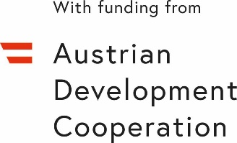
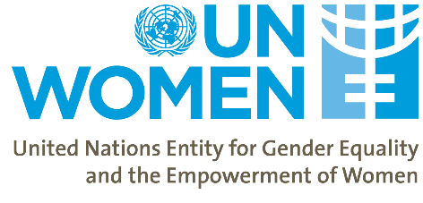
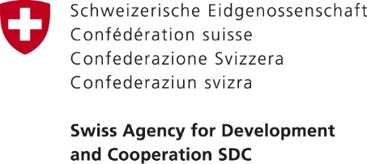

Equal Pay International Coalition (EPIC) – Taking Steps towards Closing the Gender Pay Gap in Georgia

Date: | September 18, 2020
Location: | Tbilisi, Georgia (meeting will be either fully on-line or blended i.e. face-to-face for some Georgia-based participants as well as on-line)
Organizer: | UN Women
Participants/target audience: | The event will bring together representatives of the government, private sector, trade unions and civil society from Georgia and Armenia to review the Gender Pay Gap (GPG) situation in both countries and on-going or planned interventions to close the Gap (see Annex 1 for the list of invitees).
Expected outcomes: | - Discuss Gender Pay Gap problem in Georgia and Armenia based on UN Women/SDC/ADA GPG studies.  - Increase public awareness of the commitments made by Georgia to close the Gender Pay Gap by joining EPIC.  - Participants discuss the role of various actors in addressing the GPG and review international best practices that can inform policymaking in Georgia and Armenia

BACKGROUND
Equal pay is one of the targets of the 2030 Agenda for Sustainable Development, which recognizes it as a key to inclusive growth and poverty reduction. Sustainable Development Goal 8 calls for the promotion of sustained, inclusive and sustainable economic growth; full and productive employment; and decent work for all. Equal pay is also addressed in the Beijing Declaration and Platform for Action (BPfA) as one of the indicators for women’s empowerment. Georgia has committed to fulfilling the obligations indicated by these international instruments.

The (active) Labour Code of Georgia – as the primary regulatory framework for employment relationships – does not cover the equal pay principle, nor does it specify the notion of direct and indirect discrimination. According to the International Labour Organization (ILO) Committee of Experts, the Georgian national courts have reported no cases regarding equal pay between men and women. The Committee assumes that when no cases or complaints are being lodged it is likely to indicate a lack of an appropriate legal framework, a lack of awareness of rights, a lack of confidence in, or absence of, practical access to procedures, or a fear of reprisals. The Labour Code is currently under-going a reform process and the proposed draft includes a definition of discrimination based on pay (however, this may not be the final draft that is approved).

The celebratory event is organized in the framework of the project “Women’s Economic Empowerment in the South Caucasus” (WEESC) funded by the Swiss Agency for Development and Cooperation (SDC) and Austrian Development Cooperation through the Austrian Development Agency (ADA) and implemented by UN Women. The objective of the event is to provide a platform to discuss Georgia’s commitments to the EPIC and addressing the Gender Pay Gap (GPG). The primary focus of the event is to further raise awareness around the EPIC as well as on the Government of Georgia’s commitments and plans to close the Gender Pay Gap. The event will also discuss the role of social partners in addressing the GPG aiming to increase the motivation of private sector / employers and trade unions to join EPIC.

The event will gather representatives from the Parliament of Georgia, the government agencies that are involved in policy level decisions, data production and analysis on the GPG from Armenia and Georgia (i.e. Ministry of Economy and Sustainable Development (MoESD) of Georgia; Department of Labour under the Ministry of Internally Displaced Persons from the Occupied Territories, Labor, Health and Social Affairs (MoIDPOTLHSA) of Georgia; GEOSTAT; and (depending on the epidemiological situation and international travel restrictions) representatives of the Ministry of Labour and Social Affairs of Armenia; and ARMSTAT. In addition, the event will include representatives from the Trade Unions and Employers’ Associations of Armenia and Georgia and key civil society organizations.
The programme will be divided into the following sections:
- Press briefing and public signing ceremony – Georgia joining the EPIC
- Panel discussion on Gender Pay Gap and the role of various partners in closing it

The following outlines possible scenarios depending on the epidemiological situation in Georgia at the time of the event.

Scenario A: An event that will have the majority of colleagues from Georgia together in one physical space (e.g. hotel, conference facility) while participants from Armenia, Dr. Sylvie Durrer and her colleague from the Swiss Federal Office for Gender Equality as well as those stakeholders from Georgia who are unable to come to conference venue joining on-line (draft agenda of scenario A attached). This event will include a signing ceremony with media present.

Scenario B: An event that will be fully online (draft agenda of scenario B attached). The event will be widely promoted including through UN Women Georgia social media (Facebook) page.

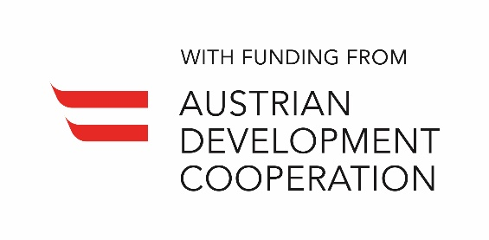

Equal Pay International Coalition (EPIC) – Taking Steps towards Closing the Gender Pay Gap in Georgia
Agenda - Scenario A (blended partially on-line meeting)

Venue: Tbilisi, Georgia

Date: September 18 2020

Time: 9:30 – 14:30
Time | Agenda Item
9:30 – 10:00 | Welcome Coffee
10:00 – 10:30 | Media Press Conference  Signing Ceremony for Georgia to join the EPIC Coalition  - Ekaterine Tikaradze, Minister of IDPs from the Occupied Territories, Labour, Health and Social Affairs of Georgia
10:30 – 11:00 | Opening remarks  - Ms. Ekaterine Tikaradze, Minister of IDPs from the Occupied Territories, Labour, Health and Social Affairs of Georgia  - Ms. Lela Akiashvili, Prime Ministers Advisor on Human Rights and Gender Equality Issues (Georgia)  - TBD, Deputy Minister, Ministry of Labour and Social Affairs of Armenia  - Dr. Sylvie Durrer, Director of the Swiss Federal Office for Gender Equality (live screened).  - Dr. Danielle Meuwly, Regional Director, Swiss Cooperation Office for the South Caucasus  - H.E. Ambassador of Austria to Georgia  Panel hosted and moderated by Dr. Sabine Machl, UN Resident Coordinator
11:00 – 12:50 | Panel Discussion: Gender Pay Gap challenge and how to join forces to close it  Moderator: Ms. Tamar Sabedashvili, UN Women Deputy Country Representative  - Gender Pay Gap situation in Georgia (UN Women)  - Gender Pay Gap situation in Armenia (ARMSTAT)  - Addressing Gender Pay Gap, lessons from Switzerland (Representative from Swiss Federal Office for Gender Equality or the EPIC Secretariat)  - Measures foreseen by the Ministry responsible for Labour to address the Pay Gap (Georgia)  - The work of the Trade Unions vis-à-vis Gender Pay Gap (Representative of Georgian Trade Unions)  - The role of employers to address the Pay Gap (Representative of Employers’ Association, Georgia)  Q&A session
12:50-13:00 | Closing remarks  Ms. Lela Akiashvili, Prime Ministers Advisor on Human Rights and Gender Equality Issues (Georgia)
13:00 – 14:30 | Lunch

Equal Pay International Coalition (EPIC) – Taking Steps towards Closing the Gender Pay Gap in Georgia
Agenda – Scenario B (fully on-line meeting)

Venue: Virtual Platform (Microsoft Teams or Skype for Business)

Date: September 18 2020

Time: 11:00 – 13:10

Time | Agenda Item
11:00 – 11:30 | Opening remarks  - Ms. Ekaterine Tikaradze, Minister of IDPs from the Occupied Territories, Labour, Health and Social Affairs of Georgia  - Ms. Lela Akiashvili, Prime Ministers Advisor on Human Rights and Gender Equality Issues (Georgia)  - TBD, Deputy Minister, Ministry of Labour and Social Affairs of Armenia  - Dr. Sylvie Durrer – Director of the Swiss Federal Office for Gender Equality (live screened).  - Dr. Danielle Meuwly, Regional Director, Swiss Cooperation Office for the South Caucasus  - H.E. Ambassador of Austria to Georgia  Panel hosted and moderated by Dr. Sabine Machl, UN Resident Coordinator
11:30 – 13:00 | Panel Discussion: Gender Pay Gap challenge and how to join forces to close it  Moderator: Ms. Tamar Sabedashvili, UN Women Deputy Country Representative  - Gender Pay Gap situation in Georgia (UN Women)  - Gender Pay Gap situation in Armenia (ARMSTAT)  - Addressing Gender Pay Gap, lessons from Switzerland (Representative from Swiss Federal Office for Gender Equality or the EPIC Secretariat)  - Measures foreseen by the Ministry responsible for Labour to address the Pay Gap (Georgia)  - The work of the Trade Unions around the Gender Pay Gap (Representative of Georgian Trade Unions)  - The role of employers to address the Pay Gap (Representative of Employers’ Association, Georgia)  Q&A session
13:00 – 13:10 | Closing remarks  Ms. Lela Akiashvili, Prime Ministers Advisor on Human Rights and Gender Equality Issues (Georgia)

Annex 1: List of invitees / participants
Government representatives
 | 1 person | Chair of the Parliament Gender Equality Council
 | 3 persons | Representatives of the GEC
 | Lela Akiashvili | Inter-Agency Commission on Gender Equality, Violence against Women and Domestic Violence
 | Ekaterine Tikaradze | Minister of Internally Displaced Persons from the Occupied Territories, Labour, Health and Social Affairs
 | 10 people | Ministry of Internally Displaced Persons from the Occupied Territories, Labour, Health and Social Affairs (MoIDPOTLHSA) Department of Labour and Employment
 | 5 people | Ministry of Economy and Sustainable Development (MoESD)
 | 3 persons | GEOSTAT
 | 3 persons | Ministry of Labour and Social Affairs – Armenia
 | 3 persons | ARMSTAT
 | 3 persons | Georgian Trade Union Confederation
 | 3 persons | Georgian Employers’ Association
 | 5 persons | Representatives of Private Sector
 | 5 persons | Civil Society Organizations
 | 5 persons | Media
Donor Organizations
 | Sylvie Durrer | Director of the Swiss Federal Office for Gender Equality.
 | Danielle Meuwly | SDC
 | Tamuna Tsivtsivadze | SDC
 | Austrian Ambassador | Embassy of Austria
 | Gerhard Schaumberger | ADA
 | Vakhtang Mshvidobadze | ADA
UN Representatives
 | Tamar Sabedashvili | UN Women Georgia
 | Mehjabeen Alarakhia | UN Women Georgia
 | Nani Bendeliani | UN Women Georgia
 | Ana Pashalishvili | UN Women Georgia
 | Mariana Unapkoshvili | UN Women Georgia
 | Gvantsa Asatiani | UN Women Georgia
 | Nino Natroshvili | UN Women Georgia
 | Natalya Harutyunyan | UNDP Armenia
 | Madelene Sunderstrom | UN RC Office of Armenia/UN Women
 | Sabine Machl | UN RC
 | 3 persons | UNDP Georgia
 | Kinan Al-Bahnasi | ILO Georgia

Possible Discussion Topics for Dr. Durrer
- Given Switzerland’s experience, what have been the policy interventions that have had the greatest impact on closing the Gender Pay Gap?
- What has been the role of the social partners in closing the Gender Pay Gap?
- How has the private sector responded to the increased focus on closing the Gender Pay Gap?
- Has there been any backlash to the government’s increased focus on closing the Gender Pay Gap?
- What have been the key lessons learned in policy actions for closing the Gender Pay Gap?
- What tools have been most effective in monitoring the Gender Pay Gap?
- What is the most effective thing that individuals can do to close the Gender Pay Gap?

